Flowchart For login user

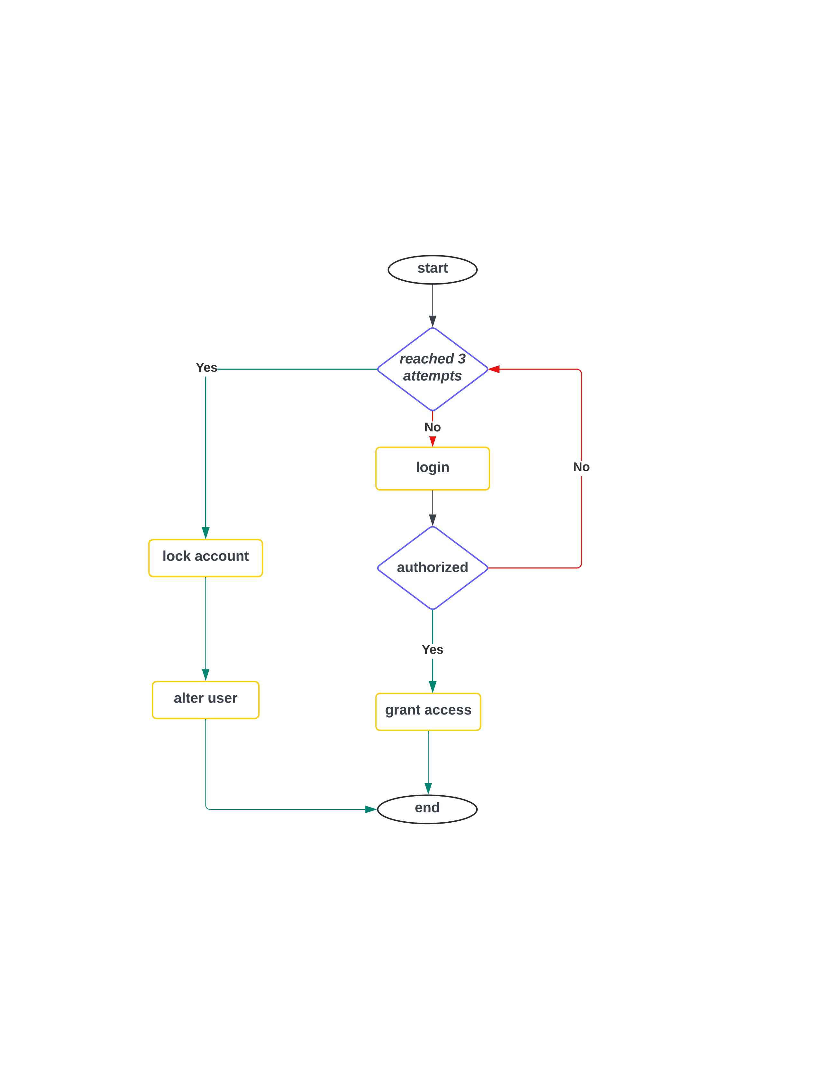

Lucid link :

***https://lucid.app/lucidchart/b39770a1-f483-4634-83e8-0b6d2060a7a5/edit?viewport_loc=267%2C-599%2C1227%2C709%2C0_0&invitationId=inv_681534e3-c55a-4d4c-abe8-a42c91e39287***